Kegiatan 1

Sw1

|  |  |  |
| --- | --- | --- |
| No | Variable | Nilai |
| 1 | Root ID |  |
| 2 | priority | 32769 |
| 3 | MAC Adrress | 0002.4A96.3AB6 |
| 4 | Bridge ID | 32769: 00E0.A364.6B9A |
| 5 | Cost (0/1;0/2;0/3) | 19 |
| 6 | Hello Time | 2 sec |
| 7 | MaxAge | 20 sec |
| 8 | Forward Delay | 15 sec |

Sw2

|  |  |  |
| --- | --- | --- |
| No | Variable | Nilai |
| 1 | Root ID |  |
| 2 | priority | 32769 |
| 3 | MAC Adrress | 0002.4A96.3AB6 |
| 4 | Bridge ID | 32769: 0002.4A96.3AB6 |
| 5 | Cost (0/1;0/2;0/3) | 19 |
| 6 | Hello Time | 2 sec |
| 7 | MaxAge | 20 sec Forward |
| 8 | Forward Delay | 15 sec |

Sw3

|  |  |  |
| --- | --- | --- |
| No | Variable | Nilai |
| 1 | Root ID |  |
| 2 | priority | 32769 |
| 3 | MAC Adrress | 0002.4A96.3AB6 |
| 4 | Bridge ID | 32769: 0060.7048.A024 |
| 5 | Cost (0/1;0/2;0/3) | 19 |
| 6 | Hello Time | 2 sec |
| 7 | MaxAge | 20 sec Forward |
| 8 | Forward Delay | 15 sec |

Ping leo ke virgo

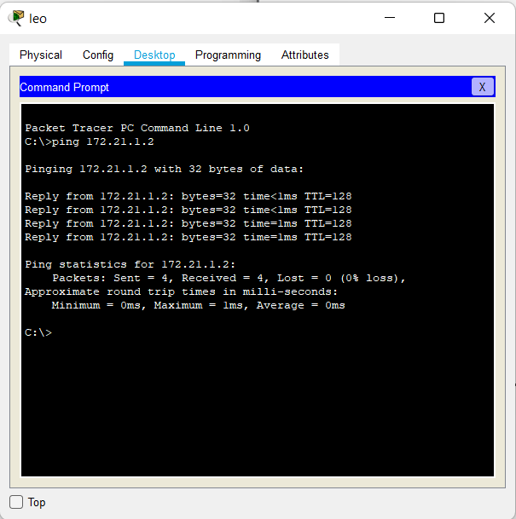

Kegiatan 2

Sw1

|  |  |  |
| --- | --- | --- |
| No | Variable | Nilai |
| 1 | Root ID |  |
| 2 | priority | 32769 |
| 3 | MAC Adrress | 0002.4A96.3AB6 |
| 4 | Bridge ID | 32769: 00E0.A364.6B9A |
| 5 | Cost (0/1;0/2;0/3) | 19 |
| 6 | Hello Time | 2 sec |
| 7 | MaxAge | 20 sec Forward |
| 8 | Forward Delay | 15 sec |

Sw2

|  |  |  |
| --- | --- | --- |
| No | Variable | Nilai |
| 1 | Root ID |  |
| 2 | priority | 32769 |
| 3 | MAC Adrress | 0002.4A96.3AB6 |
| 4 | Bridge ID | 32769: 0002.4A96.3AB6 |
| 5 | Cost (0/1;0/2;0/3) | 19 |
| 6 | Hello Time | 2 sec |
| 7 | MaxAge | 20 sec Forward |
| 8 | Forward Delay | 15 sec |

Sw3

|  |  |  |
| --- | --- | --- |
| No | Variable | Nilai |
| 1 | Root ID |  |
| 2 | priority | 32769 |
| 3 | MAC Adrress | 0002.4A96.3AB6 |
| 4 | Bridge ID | 32769: 0060.7048.A024 |
| 5 | Cost (0/1;0/2;0/3) | 19 |
| 6 | Hello Time | 2 sec |
| 7 | MaxAge | 20 sec Forward |
| 8 | Forward Delay | 15 sec |

Root port yang ada keterangan root

Root bright kalau forwading semua

Design bridge (1 switc dan dia blok)

Port 2 switch 1 blok

Kegiatan 2 nggak ada desain bridge